C++ Notes

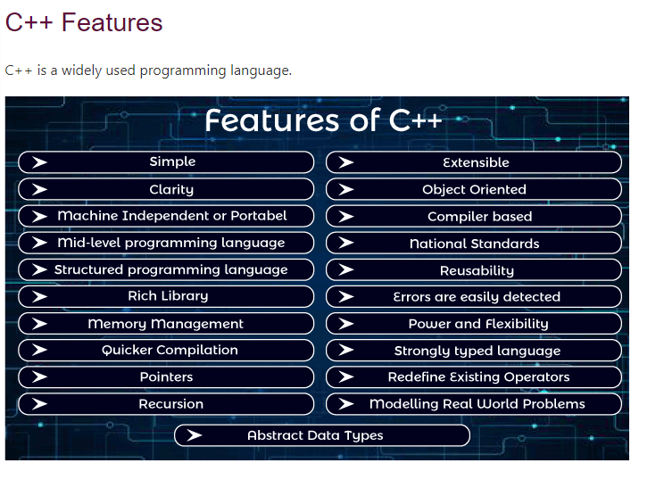

It provides a lot of features that are given below.

1. Simple
2. Abstract Data types
3. Machine Independent or Portable
4. Mid-level programming language
5. Structured programming language
6. Rich Library
7. Memory Management
8. Quicker Compilation
9. Pointers
10. Recursion
11. Extensible
12. Object-Oriented
13. Compiler based
14. Reusability
15. National Standards
16. Errors are easily detected
17. Power and Flexibility
18. Strongly typed language
19. Redefine Existing Operators
20. Modeling Real-World Problems
21. Clarity

Rich Library

C++ provides a lot of inbuilt functions that make the development fast. Following are the libraries used in C++ programming are:

* <iostream>
* <cmath>
* <cstdlib>
* <fstream>

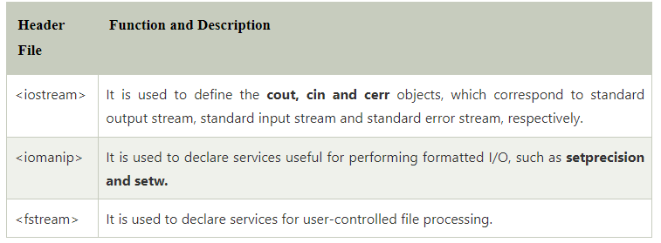

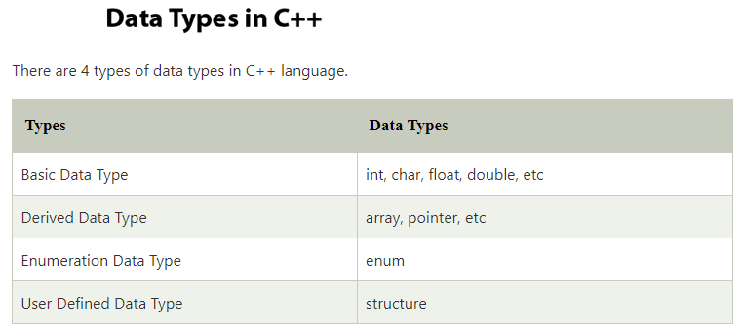

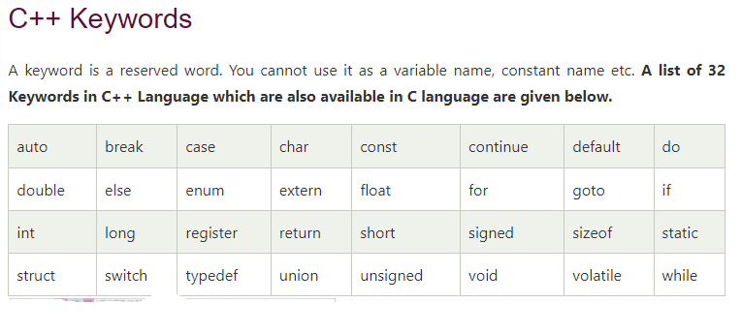

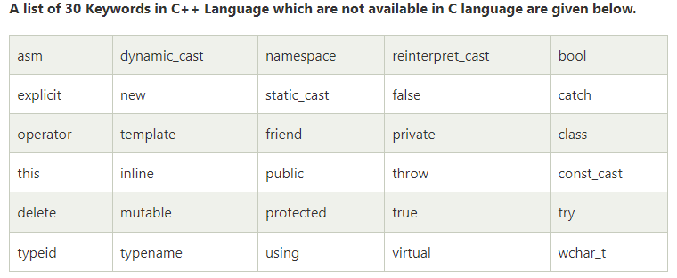

# C++ Operators

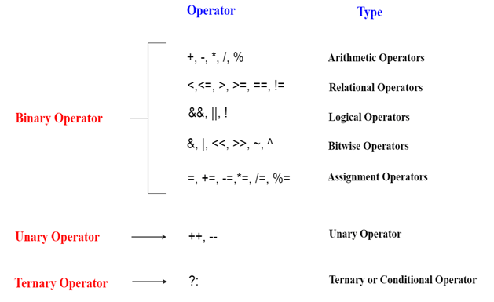

**C++ Control Statement:**

1. **if—else statement:**

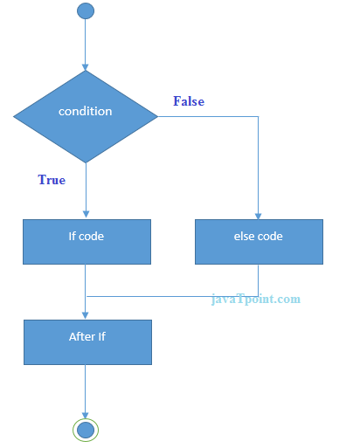

1. **Nested if—else statement:**

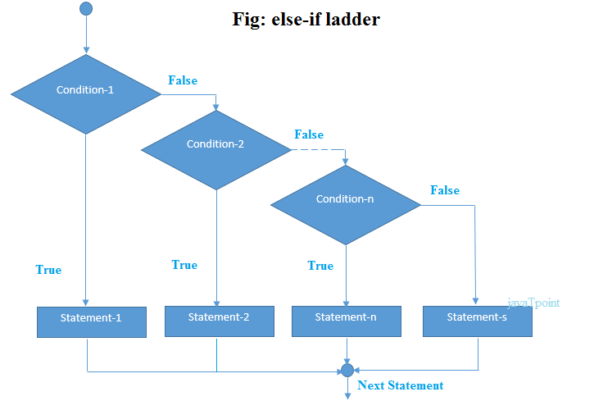

1. **Switch statement:**

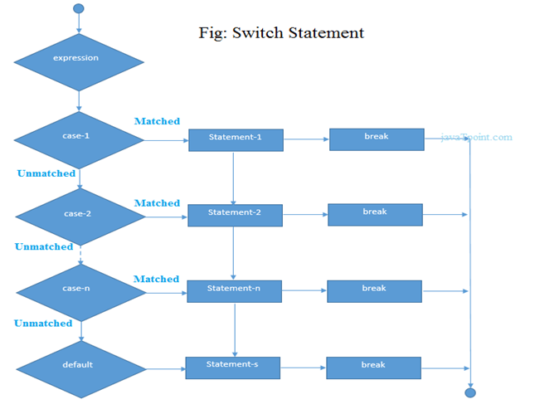

## C++ Nested For Loop

In C++, we can use for loop inside another for loop, it is known as nested for loop. The inner loop is executed fully when outer loop is executed one time. So if outer loop and inner loop are executed 4 times, inner loop will be executed 4 times for each outer loop i.e. total 16 times.

## C++ Nested While Loop

In C++, we can use while loop inside another while loop, it is known as nested while loop. The nested while loop is executed fully when outer loop is executed once.

# C++ Do-While Loop

The C++ do-while loop is used to iterate a part of the program several times. If the number of iteration is not fixed and you must have to execute the loop at least once, it is recommended to use do-while loop. The C++ do-while loop is executed at least once because condition is checked after loop body.

# Call by value and call by reference in C++

There are two ways to pass value or data to function in C language: call by value and call by reference. Original value is not modified in call by value but it is modified in call by reference.

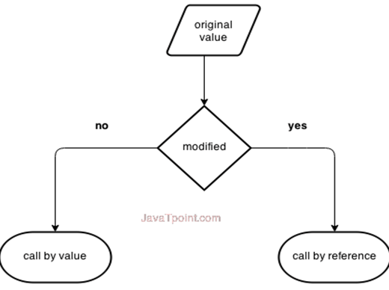

# C++ Arrays

## Advantages of C++ Array

* Code Optimization (less code)
* Random Access
* Easy to traverse data
* Easy to manipulate data
* Easy to sort data etc.

## C++ Array Types

There are 2 types of arrays in C++ programming:

1. Single Dimensional Array
2. Multi Dimensional Array